**To:** Dr. Christopher Roberts and Dr. R Bertrum Diemer, Jr

**From:** Team T - Abdul Fayeed, Adarsh Kannan, Gavin Guerrera

**Date:** May 6th, 2022

**Subject:** Progress Report #4

**Abstract**

During progress review 3, the H-mordenite catalyst was chosen over the Ion-exchange resin based on reactor sizing,catalyst costs and economics associated with both processes. Thus, the next phase of the project involved further optimization of the process flow diagram, including the recycle and separation structuring pertaining to the carbon monoxide stream. This was followed by step 5 of the Douglas method which involved heat integration in order to minimize energy consumption and reduce utility costs. This involved connecting the heat stream associated with the flash tank to the heater which follows it, and connection of the heat stream associated with the roboiler with the heater for the methanol recycle, and the addition of a heat exchanger before the carbonylation reactor. This was followed by another round of sizing, costing, VGA and NPC calculations. This was followed by conducting a risk analysis to identify potential risks, and obtain strategies to mitigate the same. Finally, this was followed up with a sensitivity analysis to determine which variable would impact the economics of this process.

**Step 5 of Douglas’ Method**

Step 5 of the Douglas method deals with heat integration (HI). The first step in this process is to classify streams as heating streams, cooling streams, and the streams which are neither heated or cooled. **Table 1** and **2** detail the heated streams which would be cooled, and the cold streams which would be heated.

**Table 1.** Detailing Cold Streams from PFD

| **Cold Stream** | **Tlow (oC)** | **Thot (oC)** | **New Label** |
| --- | --- | --- | --- |
| S7_To_S8 | 95.35 | 195.00 | C1 |
| BOTTOM_To_S14 | 14.00 | 300.00 | C2 |
| To Reboiler@B13_TO_S15 | 179.89 | 180.39 | C3 |
| To Reboiler@B7_TO_S6 | 120.01 | 127.85 | C4 |
| To Reboiler@B6_TO_S5 | 137.80 | 139.89 | C5 |
| B10_heat | -22.06 | 223.00 | C6 |

**Table 2.** Detailing Hot Streams from PFD

| **Cold Stream** | **Tlow (oC)** | **Thot (oC)** | **New Label** |
| --- | --- | --- | --- |
| To Condenser@B7_TO_S7 | 97.03 | 95.35 | H1 |
| To Condenser@B13_TO_S16 | 167.90 | 4.82 | H2 |
| To Condenser@B6_TO_S9 | 42.77 | 32.10 | H3 |
| B11_heat | 223.00 | 14.00 | H4 |
| B5_heat | 356.00 | 355.50 | H5 |

After this, the design of a heat exchanger network and maximum energy recovery were carried out. The first step in this process was to calculate the total heat to be added to the cold streams, and total heat to be removed from the hot streams. This was done by utilizing **Eq. 1**.

$Q=mC_{p}ΔT$**Eq. 1**

After the summation of the values from hot and cold streams, and taking their difference, it was determined that 15,474 kW of energy needs to be removed from the process in order to meet the first law of thermodynamics requirement. The next step involved plotting the raw hot stream and cold stream curves, which are shown in **Figure 1**.

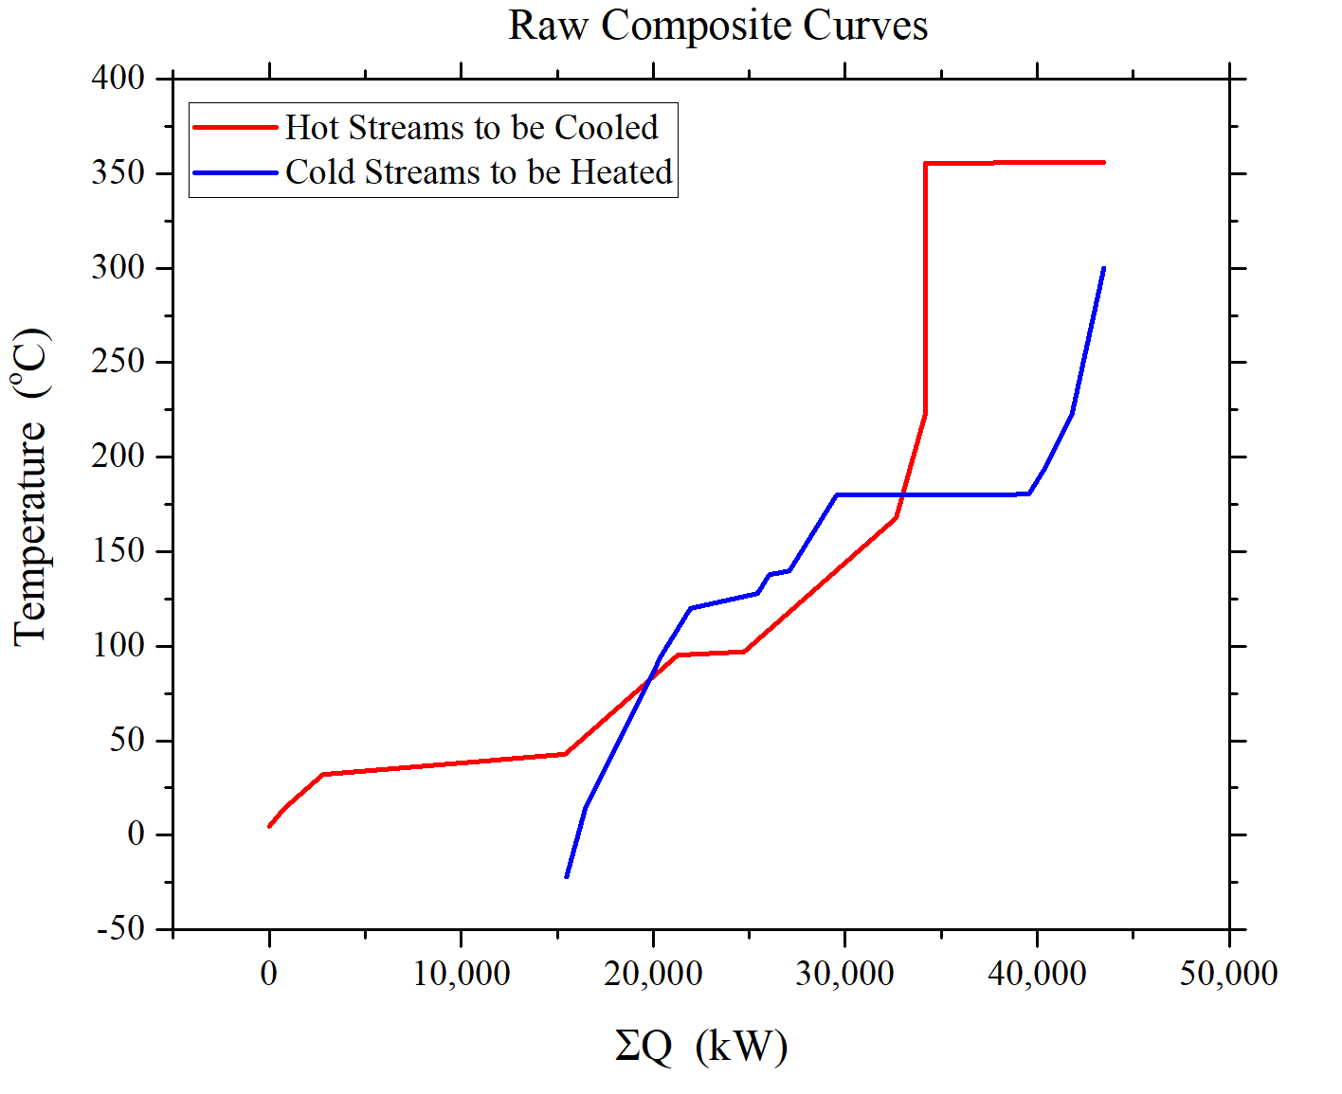

**Figure 1.** Rough Heat Composite Curve

This process clearly shows a violation of the second law of thermodynamics, as the hot streams and cold streams cross over. Hence, the next step is to build a heat cascade table in order to account for this violation. Hence, a ΔTmin of 10oC is assumed, and this value is subtracted from the initial and final value of the hot streams. After this, there is a new interval of temperature ranges for which the heat requirements are calculated. Negative values of heat requirement violate the second law of thermodynamics, which are accounted for by adding heat pertaining to the most negative value, and that value would be the pinch. The pinch temperature was determined to be 155oC. The amount of heat to be added is 4454 kW to the hot stream and 23000 kW to the cold stream. Consequently, the Minimum Energy Requirement composite curve is shown in **Figure** **2**. **Table 3** shows the new heat cascade tables.

**Table 3.** Heat Cascade Table

| **Temperature Range** | **Streams** | **ΣQ (kW)** | **Heat To Be Added (kW)** |
| --- | --- | --- | --- |
| 346.00 | H5 | 0.00 | 4454.01 |
| 345.50 | None | 9296.15 | 13750.16 |
| 300.00 | C2 | 9296.15 | 13750.16 |
| 223.00 | C2,C6 | 7642.72 | 12096.72 |
| 213.00 | H4,C2,C6 | 7155.10 | 11609.11 |
| 195.00 | C1,C2,H4,C6 | 6776.95 | 11230.96 |
| 180.40 | C3,C1,C2,C6,H4 | 6286.47 | 10740.48 |
| 179.90 | C1,C2,H4,C6 | -3715.43 | 738.58 |
| 157.91 | C1,C2,C6,H2,H4 | -4454.01 | 0.00 (PINCH) |
| 139.90 | C1,C2,C5,C6,H2,H4 | -3547.63 | 906.38 |
| 137.81 | C1,C2,C6,H4,H2 | -538.16 | 3915.85 |
| 127.86 | C1,C2,C4,C6,H2,H4 | -37.38 | 4416.63 |
| 120.02 | C1,C2,C4,C6,H2,H4 | -2652.23 | 1801.78 |
| 95.35 | C1,C2,C6,H4,H2 | -1410.91 | 3043.09 |
| 87.03 | C2,C6,H2,H4 | -887.31 | 3566.70 |
| 85.35 | C2,C6,H1,H2,H4 | 2483.67 | 6937.67 |
| 32.77 | C2,C6,H2,H4 | 5791.04 | 10245.05 |
| 22.11 | C2,C6,H4,H2,H3 | 17882.71 | 22336.72 |
| 14.00 | C2,C6,H4,H2 | 18392.61 | 22846.61 |
| 4.00 | C6,H4,H2 | 19236.40 | 23690.41 |
| -5.18 | C6,H2 | 19756.43 | 24210.44 |
| -22.07 | C6 | 19295.66 | 23749.66 |

**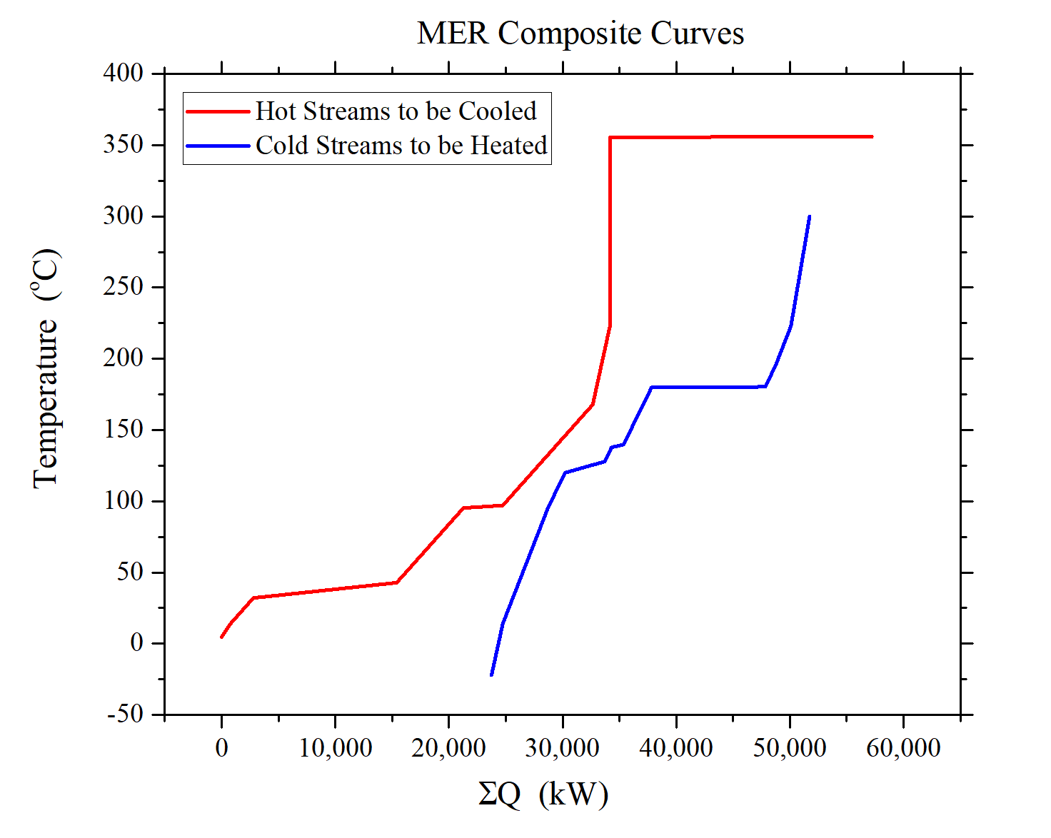  
Figure 2.** MER Composite Curve

After the composite curve, the next step involves matching of hot streams and cold streams at the pinch. The first step is to ensure that ΔTmin  is maintained. For the hot stream side, the stream matching feasibility criteria is (mCp)c > (mCp)h. From this, on the hot side, it was determined that stream H4 (feed into flash), can be cooled by the reboiler from column C2 (stream C4), as this satisfies the criterion. On the cold side, the stream matching feasibility criteria is (mCp)c < (mCp)h. From this, it was determined that stream H4 (feed into flash) will be matched with stream C1. The rest of the streams are managed by cold or hot utilities, as shown in **Figure 3.** Further detailed analysis of the heat integration is shown in **Appendix A.**

**Process Flow Diagram**

The updated block flow diagram can be seen in **Figure 3** and the Aspen screenshot can be seen in **Figure 4** below. The original methanol flow is still the same as before. However, the reactor is now being run with a coolant temperature of 315oC (DOWTHERM). The subsequent temperature profile shows a peak temperature of 356oC which is below the 400oC catalyst limit. After the Dehydration process is run the recycle structure is the same, however the DME purity was improved from 95% to 99%. This DME stream is then combined with the carbon monoxide stream which has been reduced from 600 kmol/hr to 450 kmol/hr. For the recycle stream to work correctly, an additional 100 kmol/hr of fresh hydrogen had to be added. This is because more methane was needed to obtain an optimal split between the purge and recycle. The carbonylation reactor is run with a constant coolant temperature of 190 oC of 10 bar steam. The subsequent temperature profile gives a peak temperature of 223oC. The reason for such a lower temperature for this reactor is because the carbonylation reaction is much more exothermic and could quickly raise the temperature in the reactor. It is also important to note that the catalyst mass was increased from 60,000 kg to 78,000 kg to account for the methane slowing down the reaction. The reactor exit stream is then fed to the flash tank where the majority of the carbon monoxide and methane are distilled while the methyl acetate product, methanol, and small amounts of dimethyl ether are taken from the bottom. The top flash tank stream purges some carbon monoxide, methyl acetate, and methane while the rest is run through a compressor to then be recycled. The bottom flash tank stream is sent to a fired heater to raise pressure and temperature to allow for separation to occur with small amounts of carbon monoxide. The distillate contains waste product while the bottoms contain the 99.99% pure methyl acetate product.

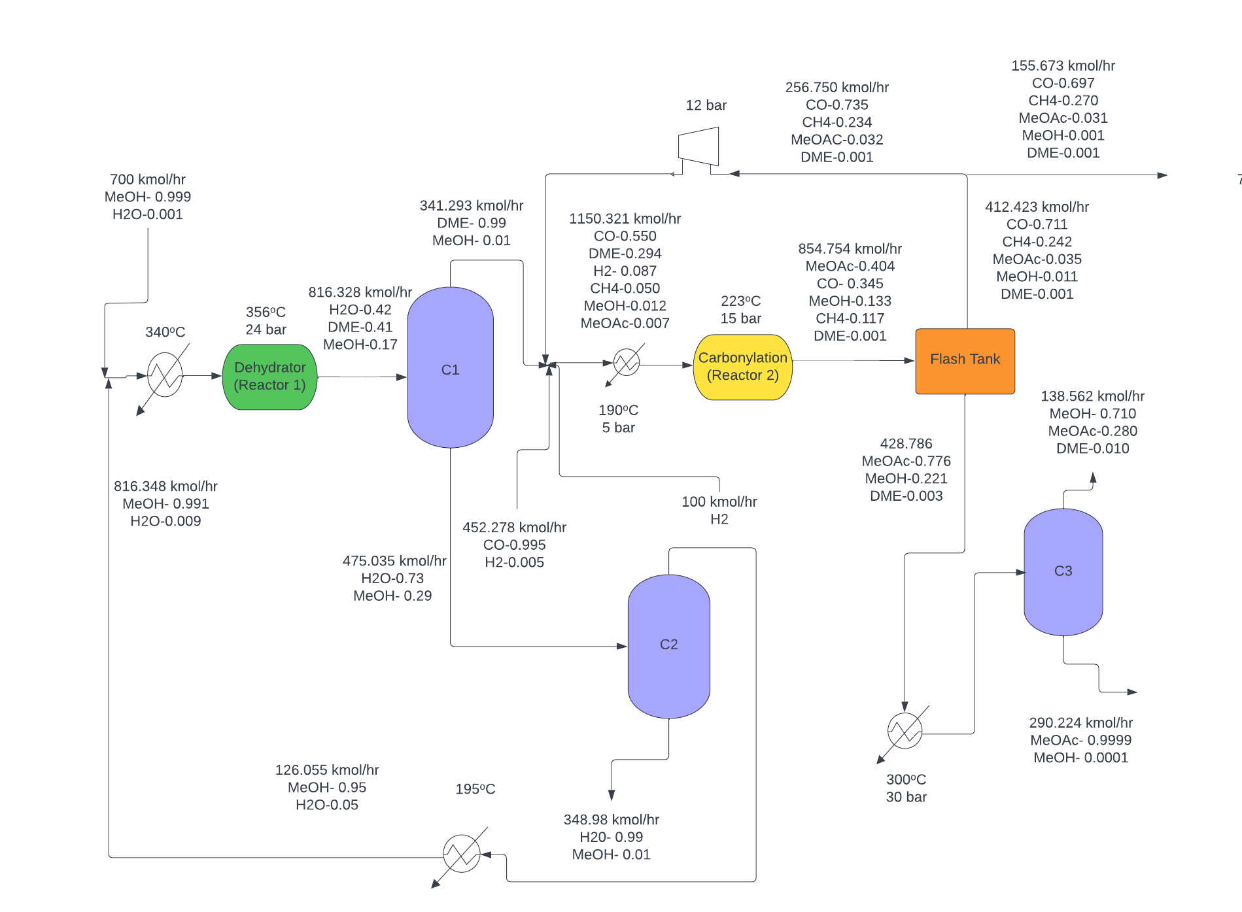

**Figure 3.** Updated Block Flow Diagram

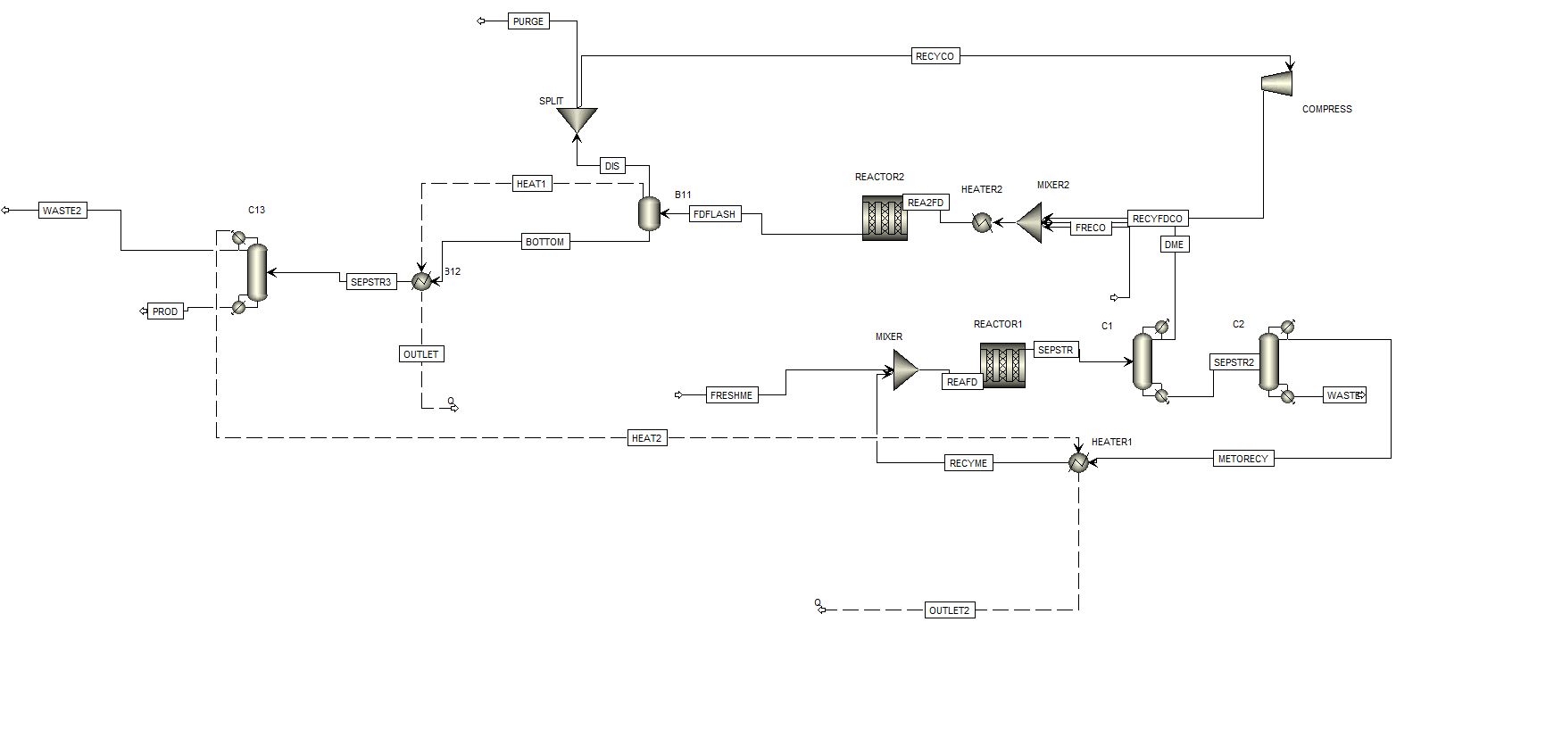

**Figure 4.** Aspen Screenshot of Process Flow Diagram

**BOE Material Sizing**

The back of the envelope (BOE) method was utilized to size all units present in the process to produce methyl acetate (MeOAc). In total, 2 reactors, 3 columns, 4 heaters, 1 flash tank, 3 reboilers, 3 condensers, and 2 mixers were used for the carbonylation process.

Reactors, reboilers, heaters, and condensers were sized by assuming they were heat exchangers. **Appendix A** shows how to find the heat-exchange area by utilizing the heat duty and design flux in the exchanger. On top of that, the flash tank is sized by acquiring a diameter and height of the column, as shown in detail in **Appendix B**. Moreover, the sizing method for a distillation column is done with the number of stages priorly determined. **Table 4** summarizes the heat-exchange area for the equipment that were sized as heat exchangers.

**Table 4.** Heat-exchange area (ft2) comparison between two catalysts.

| **Reactor 1** | 8,962 |
| --- | --- |
| **Reactor 2** | 216,704 |
| **Reboiler 1** | 312.92 |
| **Condenser 1** | 3,896.84 |
| **Reboiler 2** | 1,026.87 |
| **Condenser 2** | 1,114.24 |
| **Reboiler 3** | 3,407.06 |
| **Condenser 3** | 4,670.91 |

**Cost Analysis**

To determine the cost related to heat exchangers, it was essential to ascertain the type of heat exchanger required for the process. Thus, the change in inlet temperature, $ΔT_{in}$ was used as a measure. For < 50oC, the fixed heat heat exchanger was utilized, while for > 50oC, the floating head heat exchanger was utilized. Based on the areas calculated in sizing in **Appendix A**, the bare-module cost of the heat exchangers can be computed as shown in **Appendix C**.

To cost the distillation column, the diameters were first scaled based on the flow rates, and this is done as shown in **Appendix D**. To cost the flash tank, the diameter and length of the tank were found priorly as shown in **Appendix B**. **Appendix D** shows the detailed calculations to cost a distillation column and vertical pressure vessel (flash tank). Furthermore, **Appendix E** shows how to cost a compressor and fired heaters respectively. **Table 5** listed the comparison in bare-module costs for each equipment for both catalysts.

**Table 5.** Bare-module cost ($MM/yr) of the final process.

| **Reactor 1** | 0.244 |
| --- | --- |
| **Reactor 2** | 10.294 |
| **Reboiler 1** | 0.025 |
| **Condenser 1** | 0.080 |
| **Reboiler 2** | 0.037 |
| **Condenser 2** | 0.038 |
| **Reboiler 3** | 0.077 |
| **Condenser 3** | 0.096 |
| **Flash tank** | 0.098 |
| **Heater 1** | 0.552 |
| **Heater 2** | 0.354 |
| **Heater 3** | 0.339 |
| **Heater 4** | 1.245 |
| **Compressor** | 0.969 |
| **Column 1** | 0.862 |
| **Column 2** | 0.501 |
| **Column 3** | 0.862 |
| **Total CBM ($MM/yr)** | 16.672 |

**Sensitivity Analysis**

NROI was previously set as 25%. Sensitivity analysis was performed to see the effect of varying parameters (production rate, VGA, etc.) on the transfer price of MeOAc. The analysis was separated into three sets of parameters: 1) production rate, VGA, number of operators, and tax rate, 2) prices of catalysts, MeOH, CO, steam, electricity, cooling water, refrigerant, DOWTHERM, and operators’ wages, and 3) yield of MeOH and CO, and usage of steam, electricity, and cooling water. Each parameter was varied within ± 20 % of the original value, and the same values remained for other parameters when one was varied at a time. The goal of this analysis is to determine which parameters greatly affect the transfer price when they are varied, and automatically eliminate those who have insignificant impacts on the price relative to others. **Figure x**, **y**, and **z** show the variations of parameter set 1, 2, and 3 respectively.

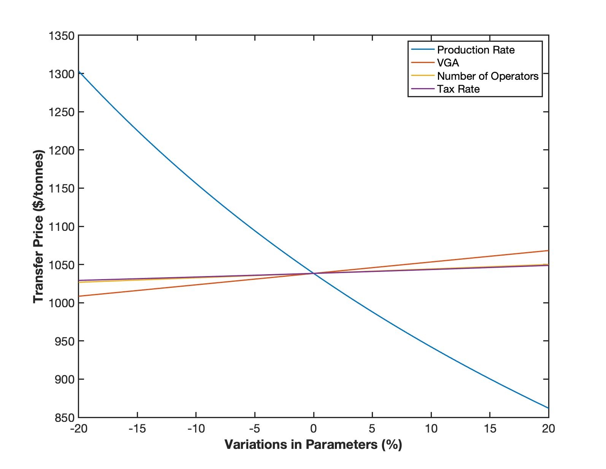

**Figure 5.** Effect of Varying Parameters in Set 1 on Transfer Price of MeOAc.

From **Figure 5**, it could be seen that varying all of the parameters has significant impacts on the transfer price. The price does not remain relatively constant (~$1040/tonnes) within the 20 % variation in parameters.

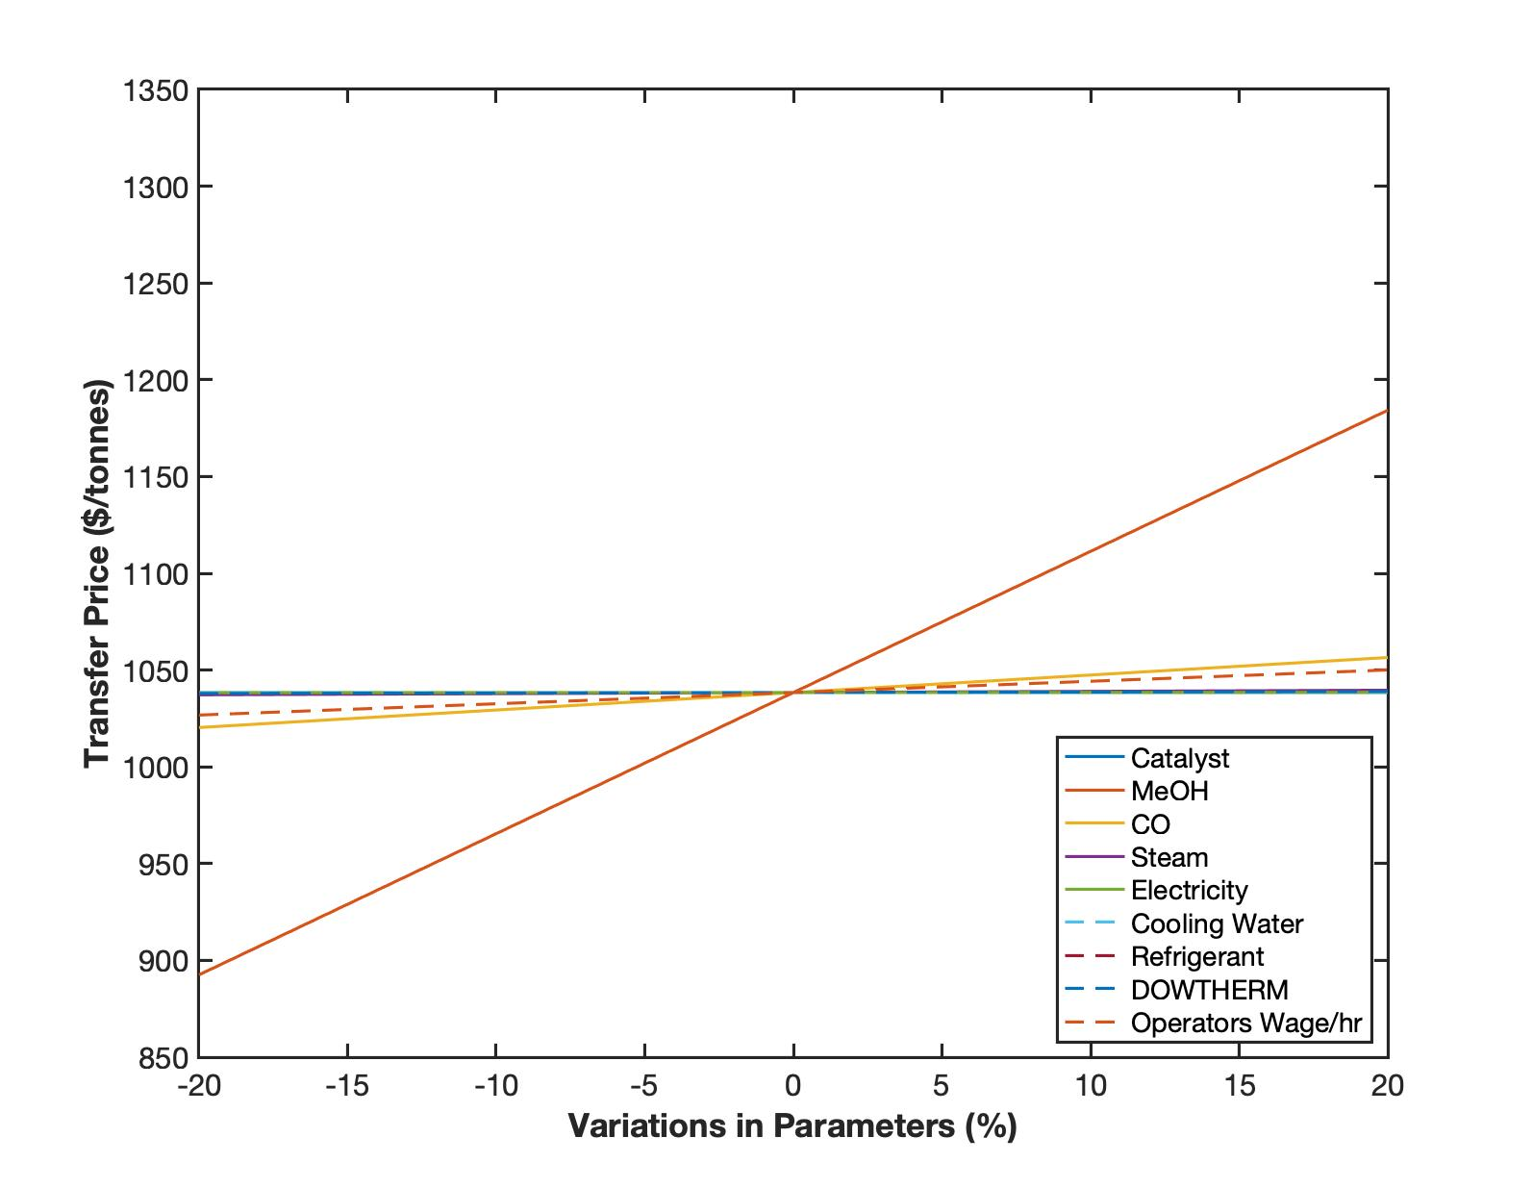

**Figure 6.** Effect of Varying Parameters in Set 2 on Transfer Price of MeOAc.

From **Figure 6**, not all parameters affect the price as much as reflected in **Figure 5**. Varying the price of MeOH and CO, as well as the operators’ wage, affect the transfer price significantly. Other parameters have insignificant effects as the transfer price remains constant around $1040/tonnes. Thus, the insignificant parameters will be ignored for further analysis.

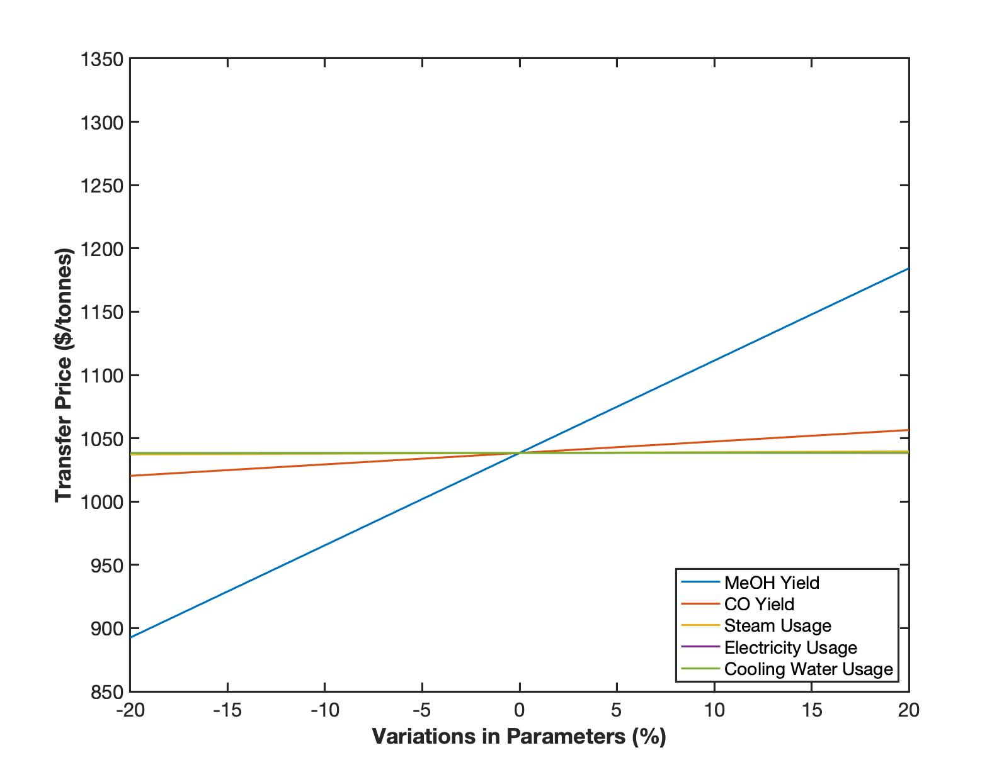

**Figure 7.** Effect of Varying Parameters in Set 3 on Transfer Price of MeOAc.

From **Figure 7**, it could be seen that the variations in the steam, electricity, and cooling water usage do not affect the transfer price that much. However, the yield of MeOH and CO affect the price significantly. Compiling all parameters that are affecting the transfer price significantly, further analysis was performed involving a Monte Carlo simulation. The simulation shows the probability of having a certain transfer price, by considering all of the significant factors that are affecting the price, as previously discussed. A cumulative probability distribution function of the transfer price is as shown in **Figure 8**.

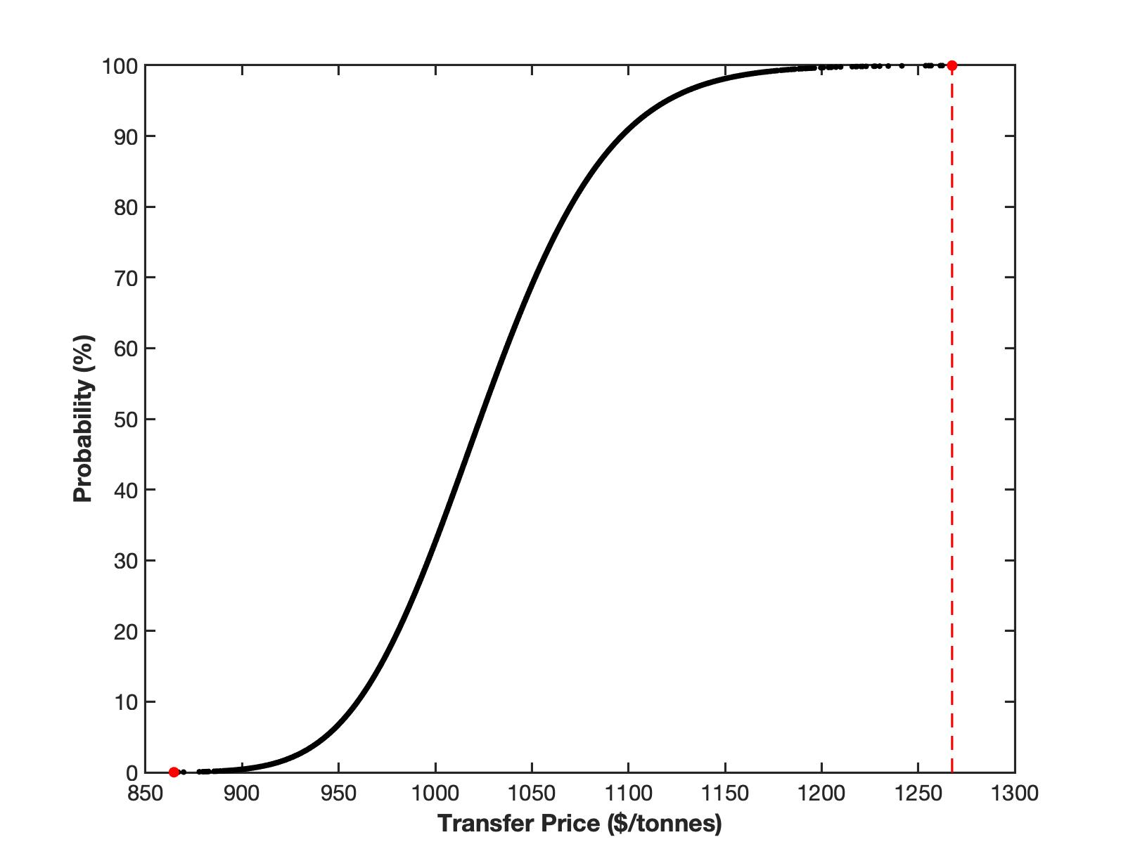

**Figure 8.** Cumulative Probability Distribution Function for Transfer Price of MeOAc.

**Figure 8** shows that the minimum and maximum transfer price that this process can achieve are $875/tonnes and $1270/tonnes respectively, with a range of approximately $400/tonnes. The median price is around $1020/tonnes.

**Risk Assessment**

Chemical Safety

Methanol- Methanol’s Exposure limit is 200 ppm over an 8 hour shift. Highly flammable even at ambient temperatures. Acute Toxicity (oral, dermal, inhalation). PPE required at all times when handling chemicals.

Dimethyl Ether- DME’s exposure limit is l000 ppm over an 8 hour shift. Extremely flammable gas that can form explosive mixtures with air. Can cause eye irritation and exposure with liquid DME can cause frostbite.

Water- Stable substance under normal conditions. Caution must be taken when dealing with phase changes, as well as interaction with organometallics.

Hydrogen: It is a colorless, odorless, cryogenic material. It has no exposure limits, with the main danger being asphyxiation due to displacement of oxygen. However, it is highly combustible and flammable, with high temperatures resulting in rupture of cylinders even before the activation of safety relief valves.

Carbon Monoxide: It is a colorless, flammable, pungent smelling gas. This affects respiratory tracts, alsong with causing eye, skin and embryonal damage. Exposure limits for carbon monoxide is 200 ppm over an 8 hour shift.

Methane: Methane is a colorless, flammable, pungent smelling gas. Inhalation of methane can lead to fatigue and nausea, while high doses could even lead to coma and death. Methane cannot be kept in confined spaces.

**Table 6.** Tabulated Risk Assessment of MeOAc Synthesis.

| **Risk** | **Probability** | **Consequence** | **Mitigation Step** | **Probability after Mitigation** | **Consequence after Mitigation** |
| --- | --- | --- | --- | --- | --- |
| Pressure Buildup | 15% | Equipment Failure | Pressure Relief Valves, Pressure Sensors | <5% | Reduced Pressure buildup with alarms for emergency |
| Chemical Leak | 10% | Fines, Hazardous Material to Atmosphere | Alarm Systems, Relief Valves/Controls | <5% | More alert workforce who can quickly stop a leak with relief systems |
| Methanol Contamination | 25% | Fines, Harm to surrounding wildlife and drinking water | Water Treatment | <5% | Costs from treatment but reputation saved. |
| MeOAc-Methanol azeotrope | 20% | Lack of pure final product resulting in significant economic loss | Mitigated by utilizing high pressure to ensure the azeotrope is not formed | <5% | Incurs penalty of additional equipment costing but ensures product purity. |
| Effect of purging Methane and CO | 100% | Greenhouse gasses would lead to global warming; CO is also toxic | Mitigated by partial flashing to obtain fuel credit | <15% | Improves the reputation of the company, reduces the effect of global warming. |
| Large Amount of CO is purged | 55% | Significant economic impact on plant operations | Addition of recycle stream | <10% | Incurs slight increase in COM but also leads to acceptable purge of Methane and CO |
| Effect of Feeding Additional Hydrogen Gas | 100% | Hydrogen is highly flammable | Ensure gas is secured in compressed, stainless steel cylinder | <10% | Prevents explosion and damage to plant. |

**Conclusion**

After choosing the H-mordenite catalyst for the dehydrator the final process was chosen. Also, we faced the issue of not having a working carbon monoxide recycle stream. This recycle stream was implemented effectively by adding fresh hydrogen gas to the carbonylation reactor feed. This allowed more methane to be produced allowing for a better separation at the split point between the recycle and purge. More amounts of catalyst were also needed for the reactor and increased costs slightly. Once this was done, heat integration was performed where composite curves were created to help identify the pinch points. Next, cold and hot streams were matched and additional heat exchangers were added. This reduced utility duties by 68%. The new system was then coated with updated bare module costs and new VGA values. These values then allowed for new NPC, Transfer Price, NPV, and IRR. Once this was done, a sensitivity analysis was performed which showed that Methanol yield was the most impactful factor. Lastly, the major risks of the plant were identified including both economic and safety issues. These included chemical leaks or pressure build ups. All risks included mitigation steps to reduce negative consequences.

**Appendices**

***Appendix A: Determination of Heat Exchange Area***

**Table A.** Various values of heat flux

| **Type of flux** | **Flux value (BTU/hr/ft2)** |
| --- | --- |
| Gas-to-gas | 300 |
| Liquid-to-liquid | 8,000 |
| Phase change | 10,000 |
| Condensing steam | 12,000 |

To find a heat exchange area, the type of flux has to be determined first in order to use the appropriate heat flux value. Assume that it is a gas-to-gas flux with a heat transfer duty of *a* BTU/hr. The heat exchange area is determined as shown in **Eq. A**.

$Heat exchange area,A=\frac{a BTU/hr}{300 BTU/hr/ft^{2}}=\frac{a}{300}ft^{2}$**Eq. A**

***Appendix B: Determining the Length and Diameter of the Flash Tank***

To find the length and diameter of the flash tank, the flow rate into the tank has to be determined first. Let’s use an arbitrary number of 1,043.16 kmol/hr as the inflow rate. This flow rate is converted to m3/hr by considering the molar composition and density of the components in the inflow.

**Table B1.** Molar composition and thermodynamics properties for each component

| **Components, i** | **Molar composition, xi** | **Molar mass, MWi (g/mol)** | **Density, ρi (g/m3)** |
| --- | --- | --- | --- |
| Methanol | 0.0043 | 32.04 | 792,000 |
| Dimethyl ether | 0.0472 | 46.07 | 2,110 |
| Water | 0.0000 | 18.02 | 997,000 |
| Carbon monoxide | 0.5191 | 28.00 | 1,140 |
| Methyl acetate | 0.4247 | 74.08 | 932,000 |
| Hydrogen | 0.0005 | 2.00 | 84 |
| Methane | 0.0043 | 16.00 | 657 |

The flow rate in kmol/hr can be converted to m3/hr by using **Eq. B1**.

$Flow rate (m^{3}/hr)=\frac{\sum_{i}^{n}{}x_{i}MW_{i}}{\sum_{i}^{n}{}x_{i}ρ_{i}}$**Eq. B1**

From the volumetric flow rate, since flash tanks can be assumed to have 5 minutes residence for half tank (10 minutes for full tank), the total volume of tank can be calculated as **Eq. B2**.

$Volume (m^{3})=Flow rate (m^{3}/hr)×10 mins×1/60 (hr/mins)$**Eq. B2**

To find the length of the tank, it is assumed to have a cylindrical shape. From the volume formula in **Eq. B3**, the diameter can be found from L/D = 2.5 relationship as priorly assumed. **Table B2** shows the length and diameter computed.

$V=π{(\frac{D}{2})}^{2}L$**Eq. B3**

**Table B2.** Diameter and Length for flash tank.

| **Parameter** | **Values (ft)** |
| --- | --- |
| Diameter | 7.23 |
| Length | 18.08 |

***Appendix C: Computing the Purchase Cost of Heat Exchanger***

The purchase cost of a heat exchanger can be calculated by using **Eq. C1**.

$C_{P}=F_{P}×F_{M}×F_{L}×C_{B}$**Eq. C1**

To solve **Eq. C1**, **Eq. C2** and **C3** have to be computed first.

$F_{P}=0.9803+0.018\left(\frac{P}{100}\right)+0.0017{\left(\frac{P}{100}\right)}^{2}$**Eq. C2**

$F_{M}=a+{\left(\frac{A}{100}\right)}^{b}$**Eq. C3**

**Table C1.** Values of FL

| **Tube length (ft)** | **FL** |
| --- | --- |
| 8 | 1.25 |
| 12 | 1.12 |
| 16 | 1.05 |
| 20 | 1.00 |

It is assumed that the tube length is more than 20 ft, thus FL is 1.00 from **Table C1**. To find FM, since the exchangers are made of carbon steel, the values of a and b are equal to 0, making FM to be 1.00. To solve for CB, **Eq. C4** and **C5** are used for floating- and fixed-head heat exchangers respectively.

$C_{B}=exp[12.031-0.8709 ln A+0.09005 (ln A)^{2}]$**Eq. C4 $C_{B}=exp[11.4185-0.9228 ln A+0.09861 (ln A)^{2}]$** **Eq. C5**

Finally, to find CBM, **Eq. C6** is used. **Table C2** summarizes the notations used in all equations.

$C_{BM}=F_{BM}×C_{P}$**Eq. C6**

**Table C2.** Notation used in heat exchangers cost determination

| **Notation** | **Definition** | **Unit** |
| --- | --- | --- |
| CP | Purchase cost | $ |
| FP | Pressure factor | - |
| FM | Material factor | - |
| FL | Tube length factor | - |
| CB | Base cost | $ |
| A | Heat exchange area | ft2 |
| P | Pressure | psi |
| a | FM factor | - |
| b | FM factor | - |
| CBM | Bare-module cost | $ |
| FBM | Bare-module factor | - |

***Appendix D: Computing the Purchase Cost of Distillation Column/Vertical Pressure Vessel***

The purchase cost of a distillation column or vertical pressure vessel can be calculated by using **Eq. D1**.

$C_{P}=F_{M}×C_{V}+C_{PL}+C_{T}$**Eq. D1**

To solve **Eq. D1**, **Eq. D2 - D7** have to be computed first.

$C_{PL}=341(D_{i})^{0.63316}(L )^{0.80161}$**Eq. D2**

$C_{T}=N_{T}×F_{NT}×F_{TT}×F_{TM}×C_{BT}$**Eq. D3**

$F_{NT}=\frac{2.25}{1.0414^{N_{T}}}$**Eq. D4**

$C_{BT}=468 exp(0.1482×D_{i})$**Eq. D5**

$C_{V}=exp\{7.139+0.18255 ln W+0.02297(ln W)^{2}\}$**Eq. D6**

$W=ρt_{s}π(D_{i}+t_{s})(L+0.8D_{i})$**Eq. D7**

$t_{p}=\frac{P_{d}D_{i}}{2SE-1.2P_{d}}$**Eq. D8**

Finally, to find CBM, Eq. G6 is used. **Table D** summarizes the notations used in all equations.

$C_{BM}=F_{BM}×C_{P}$**Eq. D9**

**Table D.** Notation used in distillation column/vertical pressure vessel cost determination

| **Notation** | **Definition** | **Unit** |
| --- | --- | --- |
| CP | Purchase cost | $ |
| FM | Material factor | - |
| CV | Empty vessel cost | $ |
| CPL | Platform/ladder cost | $ |
| CT | Tray cost | $ |
| NT | Number of trays | - |
| FNT | Tray number factor | - |
| FTT | Tray type factor | - |
| FTM | Tray material factor | - |
| CBT | Base tray cost | $ |
| Di | Inner diameter | ft |
| L | Length | ft |
| W | Vessel weight | lb |
| ρ | Metal density | lb/ft3 |
| /ts | Shell thickness | ft |
| CBM | Bare-module cost | $ |
| FBM | Bare-module factor | - |

***Appendix E: Computing the Purchase Cost of Compressor***

To size a compressor since it is used in the carbonylation process, **Eq. E1 - E3** represent the equations used to find the base cost CB of a centrifugal, reciprocating, and screw compressor, with a consumed power PC range of 200 ≤ PC ≤ 30,000 Hp, 100 ≤ PC ≤ 20,000 Hp, and 10 ≤ PC ≤ 750 Hp respectively.

$C_{B}=exp\left[9.1553+0.63ln\left(P_{C}\right)\right]$**Eq. E1**

$C_{B}=exp\left[4.6762+1.23ln\left(P_{C}\right)\right]$**Eq. E2**

$C_{B}=exp\left[8.2496+0.7243ln\left(P_{C}\right)\right]$**Eq. E3**

With engineering assumptions and appropriate power consumed by the process, the base cost can be calculated in order to find the purchase cost CP, as shown in **Eq. E4**.

$C_{P}=F_{D}F_{M}C_{B}$**Eq. E4**

The turbine drive factor FD and material type factor FM can be determined as listed in **Table E1** and **E2**. From CP, the bare-module cost CBM can be computed as shown in **Eq. E5**. The bare-module factor of a compressor is 2.15.

**Table E1.** Values of FD for different type of turbine drive

| **Type of drive** | **Values of FD** |
| --- | --- |
| Steam turbine | 1.15 |
| Gas turbine | 1.25 |

**Table E2.** Values of FM for different type of turbine materials

| **Type of materials** | **Values of FM** |
| --- | --- |
| Stainless steel | 2.5 |
| Nickel alloy | 5.0 |

$C_{BM}=F_{BM}C_{P}$**Eq. E5**

***Appendix F: Computing the Purchase Cost of Fired Heater***

To size the fired heater, **Eq. F1** is used to solve for its base cost for a heat duty Q range of 10 ≤ Q ≤ 500 MM BTU/hr. The purchase cost is computed by using **Eq. F2**.

$C_{B}=exp\left[-0.15241+0.785ln\left(Q\right)\right]$**Eq. F1**

$C_{P}=F_{P}F_{M}C_{B}$**Eq. F2**

The pressure factor FP is calculated from **Eq. F3**, with a pressure P range of 500 ≤ P ≤ 3,000 psig.

$F_{P}=0.986-0.0035\left(\frac{P}{500}\right)+0.0175{\left(\frac{P}{500}\right)}^{2}$**Eq. F3**

Again, engineering assumptions have to be made in terms of choosing the materials for fired heaters to be economically feasible and safe to operate. The material factor FM is as listed in Table z.

**Table F1.** Values of FM for different type of heater materials

| **Type of materials** | **Values of FM** |
| --- | --- |
| Cr-Mo alloy | 1.4 |
| Stainless steel | 1.7 |

Lastly, the bare-module cost can be computed from **Eq. F4** with FBM values of between 1.86 (field-fabricated fired heaters) and 2.19 (shop-fabricated fired heaters).

$C_{BM}=F_{BM}C_{P}$**Eq. F4**

***Appendix G: Determination of Batch vs Continuous Process***Now, it has been stated that the desired acetic anhydride (Ac)2O and methyl acetate (MeOAc) production are 500 and 375 MMppy. Thus, to obtain the mass amount per year, the following calculations were carried out.

$500⋅10^{6}\frac{lb}{yr}×\frac{1kg}{2.205lb}×\frac{1 ton}{1000kg}=226,796 tonnes/yr$

$375⋅10^{6}\frac{lb}{yr}×\frac{1kg}{2.205lb}×\frac{1 ton}{1000kg}=170,097 tonnes/yr$

This value is greater than 5,000 tonnes/yr, which proves that the continuous process is preferred to the batch process in this scenario.

***Appendix H. Calculations for Energy/Heat Integration***

In order to determine the mCp values for the hot and cold streams, the enthalpy of the streams are required. These were obtained from Aspen, along with the inlet and outlet temperatures. Consequently, the mCp values were calculated by **Eq. H1**.

$mCp=\frac{Q}{|Tout-Tin|}$**Eq. H1**

Hence, the mCp values for the streams are given below in **Table H1**.

**Table H1.** mCp values for Hot and Cold Streams

| **Stream** | **Thot (K)** | **Tcold (K)** | **Enthalpy Flow (kW)** | **mCp (kJ/K)** |
| --- | --- | --- | --- | --- |
| C1 | 245.05 | 47.48 | 4623.91 | 23.40 |
| C2 | 210.00 | 198.33 | 265.66 | 22.76 |
| C3 | 175.55 | 174.99 | 2679.19 | 4787.64 |
| C4 | 198.99 | 183.74 | 1634.24 | 107.21 |
| C5 | 358.18 | 210.00 | 608.20 | 4.10 |
| C6 | 358.18 | 210.00 | 608.20 | 4.10 |
| H1 | 358.17 | 341.00 | 319.17 | 18.58 |
| H2 | 151.91 | 151.84 | 1861.44 | 26241.08 |
| H3 | 115.29 | 59.77 | 2088.97 | 37.62 |
| H4 | 341.00 | 90.00 | 6651.09 | 26.49 |
|  |  |  |  |  |

Based on the mCp values, along with the Tin and the Tout, the initial hot and cold stream tables can be determined. From these, the total heat needed to be added and removed are calculated and as summarized in **Table H2** and **H3**.

**Table H2**: Hot Streams heat removal

| **Temperature Interval (oC)** | **Streams** | **ΣQ[kW]** |
| --- | --- | --- |
| 59.77 | - | 0.00 |
| 90.00 | H3 | 1137.24 |
| 115.29 | H3, H4 | 2759.25 |
| 151.85 | H4 | 3727.87 |
| 151.92 | H4, H2 | 5591.19 |
| 341.00 | H4 | 10601.51 |
| 358.18 | H1 | 10920.69 |

**Table H3**: Cold Streams heat addition

| **Temperature Interval (oC)** | **Streams** | **ΣQ[kW]** |
| --- | --- | --- |
| 47.48 | - | 0.00 |
| 174.99 | C1 | 2984.20 |
| 175.55 | C1, C3 | 5676.49 |
| 183.74 | C1 | 5868.31 |
| 198.33 | C1, C4 | 7773.22 |
| 198.99 | C1, C4, C2 | 7874.30 |
| 210.00 | C1, C2 | 8382.68 |
| 245.05 | C5, C1 | 9346.88 |
| 358.18 | C5 | 9811.20 |

Based on these values, the initial cascade plot was built, which violated the first and second law of thermodynamics. These values are shown in the main report along with the main heat cascade table. The updated hot and cold stream values are shown in **Table H4** and **H5**.

**Table H4**: Updated hot streams heat removal

| **Temperature Interval (oC)** | **Streams** | **ΣQ[kW]** |
| --- | --- | --- |
| 59.77 | - | 0.00 |
| 90.00 | H3 | 1137.24 |
| 115.29 | H3, H4 | 2759.25 |
| 151.85 | H4 | 3727.87 |
| 151.92 | H4, H2 | 5591.19 |
| 341.00 | H4 | 10601.51 |
| 358.18 | H1 | 13294.48 |

**Table H5**: Cold Streams heat addition

| **Temperature Interval (oC)** | **Streams** | **ΣQ[kW]** |
| --- | --- | --- |
| 47.48 | - | 3483.28 |
| 174.99 | C1 | 6467.48 |
| 175.55 | C1, C3 | 9159.77 |
| 183.74 | C1 | 9351.59 |
| 198.33 | C1, C4 | 11256.50 |
| 198.99 | C1, C4, C2 | 11357.58 |
| 210.00 | C1, C2 | 11865.95 |
| 245.05 | C5, C1 | 12830.16 |
| 358.18 | C5 | 14403.48 |

After this process is completed, stream matching takes place, based on the criteria shown in the lecture. The stream matching is shown in the main report. **Table H6** and **H7** tabulate the final stream matching values.

**Table H6**: C2 - H4 cold stream matching

| **Temperature Interval (oC)** | **Heat (kW)** |
| --- | --- |
| Heating C1 | 5984.20 |
| Cooling H1 | 2517.07 |
| Excess: | 3467.13 |

**Table H7**: C1 - H2 cold stream matching

| **Temperature Interval (oC)** | **Heat (kW)** |
| --- | --- |
| Heating of C3 | 2679.19 |
| Cooling of H4 | 4134.03 |
| Heat to be Removed | -1454.83 |